# Two-Phase

**Overview**

In this tutorial, an instantaneous tailings dam failure with water storage is simulated. It is assumed that the water storage rests over the tailing's material. Initially, the water is released and scours the stationary tailings material in reservoir at the breach as the breach expands. Then, the water and sediment mixture with a low concentration scours the moving tailings material as it liquefies (mudflow phase). Finally, the fluid phase continues to scour the downstream bed as the fluid races ahead of the mudflow until the sediment concentration reaches the hyperconcentrated sediment flow level.

**Required Files**

The step makes use of Tailings Area. The required data is available at C:\Users\Public\Documents\FLO-2D PRO Documentation\Example Projects\Tailings Dam Breach Workshop\data\

|  |  |  |
| --- | --- | --- |
| File | Content | Location |
| Tailings Area.shp | Tailings Area | ..\Tailings Dam Breach Workshop\data\ |

## Step 1: Delete the reservoir Initial Condition

1. In this lesson, another initial condition will be used. Under Initial Condition Editor, click on Delete Current Reservoir.

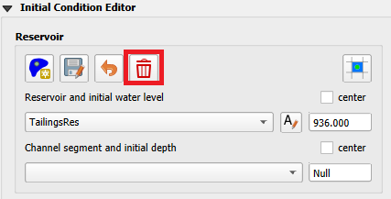

1. Click Yes to delete the reservoir.

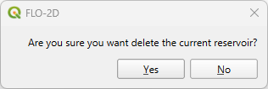

1. Click on schematize Initial Conditions to clear the information stored on the geopackage. Click yes to close the message and complete the process.

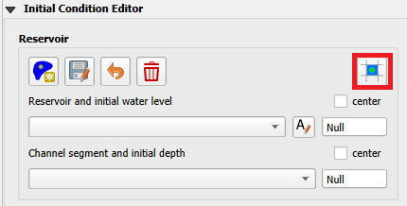 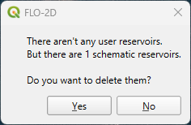

## Step 2: Set-up the stacks initial condition

A collapse of the tailing's facility can be simulated without using the prescribed breach failure data in the LEVEE.DAT file. This is accomplished by assigning tailings depths to the grid elements within tailings facility. When the FLO-2D model is run with the levee dam cells removed, the storage tailings begin to move immediately.

1. Drag the Tailings Area onto map space.

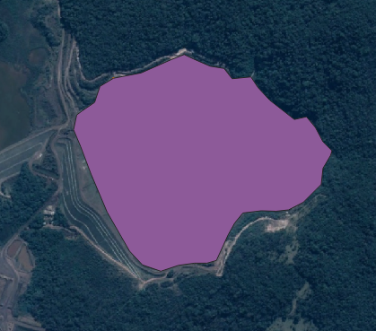

The tailings area is set to approximately 1/3 of the Dam height to match the volume released.

1. Under the Initial Condition Editor Tailings Stack, check User Polygon and select the Tailings Area shapefile. Set the tailings elevation to 936 and the Water Surface elevation to 940, click on Export Tailings Depth, and set the export folder to Export Two-Phase.

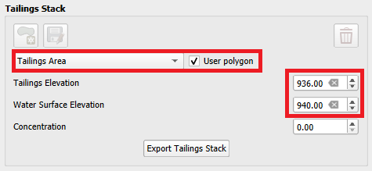

1. Click OK & No to not remove the intermediate calculation shapefiles.

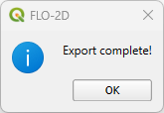 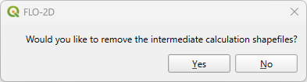

1. On the Export Two-Phase folder, a file named TAILINGS_STACK_DEPTH.DAT is created. This file contains all the grid elements, water depth on the surface of the tailings and tailings depth. This file is required for creating an instantaneous static or seismic failure.

## Step 3: Review two-phase properties

Each variable is discussed in the Data Input Manual SED.DAT. This data may be available from the original dam construction manual or from periodical safety reports. Data for this tutorial was found in reports for the tailing dam failure. Check with the dam owner, or dam safety agency for data.

* + 1. Click Mud and Sediment Transport icon in the toolbar.

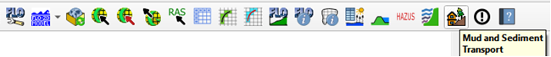

* + 1. Select the radio button for Two Phase Modeling.

* 1. Enter Mud /Debris Transport Parameters from the following table.

|  |  |
| --- | --- |
| **Value** | **Description** |
| 2.65 | Mudflow Specific Gravity |
| 0 | Laminar Flow Resistance |
| Glenwood 4 | Viscosity & Yield Stress Relationship |

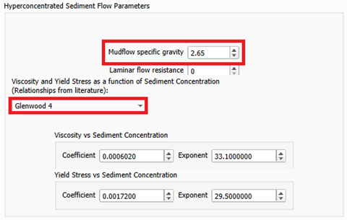

* 1. Enter the Sediment Transport Parameters

|  |  |
| --- | --- |
| **Value** | **Description** |
| Yang | Sediment Transport Equation |
| 2.65 | Sediment specific gravity |
| 0.12 | Sediment size (D50) in mm |
| 0.0778 | Global fine sediment volumetric concentration |
| 14700 | Dry specific weight sediment |
| 3.71 | Gradation coefficient |
| 3 | Max allowable scour depth |

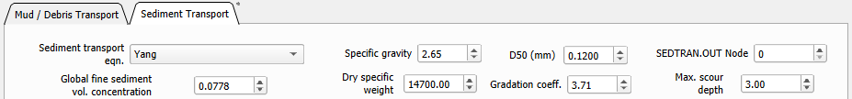

1. Scroll to the bottom and click OK to save the data.

## Step 4. Run the two-phase simulation

1. Open the Control Variables. Increase the Bulking Concentration to 0.5. Uncheck the Levee from the System Components Switches. Select the Two-Phase as the Mud/Debris/Sediments physical process. Click save.

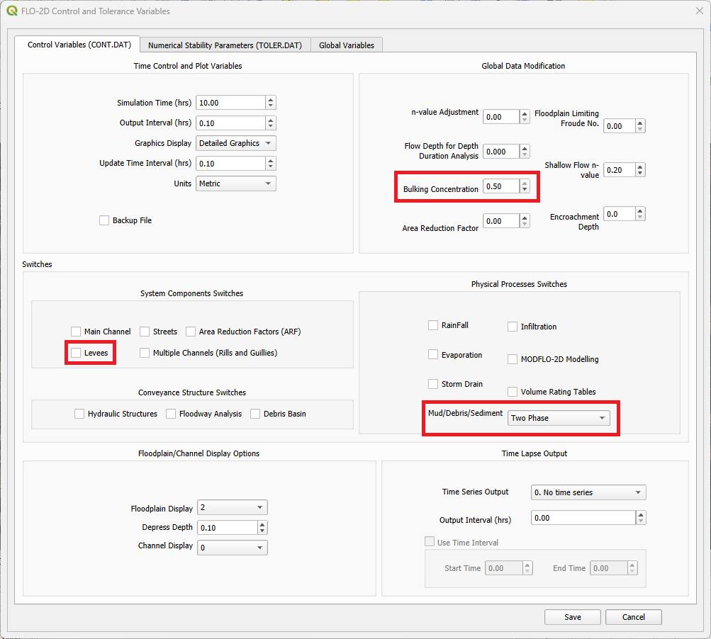

1. Click the main Save icon on the QGIS toolbar.

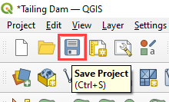

1. Click the FLO-2D Data Export icon, select the previously created Export Two-Phase folder and select it.



The two-phase guidelines are installed with FLO-2D Software. "C:\Users\Public\Documents\FLO-2D PRO Documentation\flo_help\Manuals\Two Phase Flood Routing Guidelines 2022.pdf"

1. Make sure to uncheck Levees, Rain, and Infiltration.

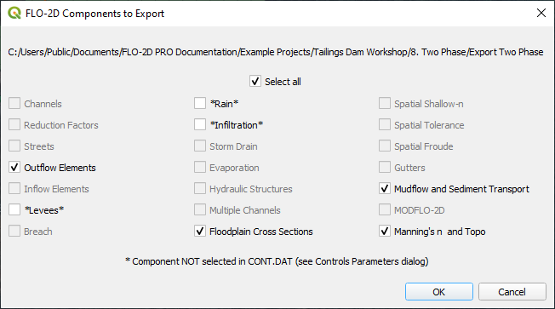

1. Click on the Run FLO-2D Pro to run the simulation.

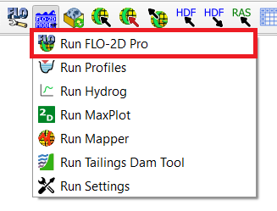

1. Check the simulation summary for any potential errors.

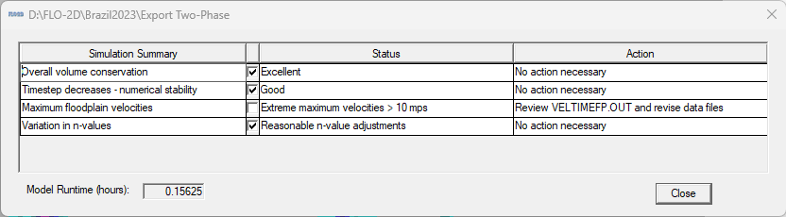

## Step 5. Check the results

1. Use FLO-2D-Rasterizor or MaxPlot to check the results.
2. **Rasterizor:** Select the DEPTHMAX_2PHASE_COMBINED.OUT input file to visualize the combined two-phase results.

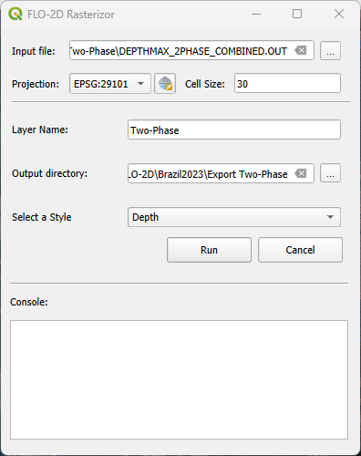

1. **Rasterizor:** Select the DEPTH.OUT input file to visualize the fluid phase results.

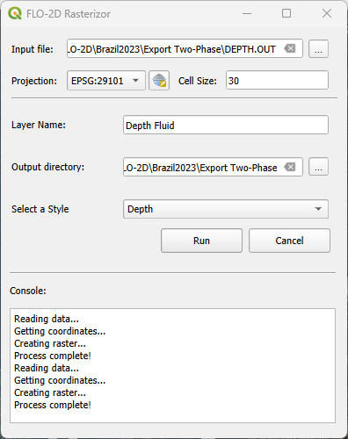

1. **Rasterizor:** Select the DEPFPMAX_MUD.OUT input file to visualize the mudflow phase results.

